# LAB REPORT

# Lab 1: Modelling and Simulation Using Matlab

# Lab Date: Monday October 21, 2019

# Submission Date: Wednesday October 23, 2019

# Prelab: 2 marks

# Lab Report: 4 marks

# Lab Work: 4 marks

|  |  |
| --- | --- |
| Name | Student Number |
| Bingran Li | 1004191910 |
| Omar Elzaria | 1004095739 |
|  |  |

## 3.1 Building the SIMULINK Model

3.1.1 (0.5 mark) Write down the two functions in the space below:

$$\dot{x}=f\left(x,u\right)=\left\{\begin{aligned}x_{2} \\ \frac{{x_{3}}^{2}}{{x_{1}}^{2}}-9.8 \\ -3x_{3}+u\end{aligned}\right.$$

$$y=h\left(x,u\right)=x_{1}$$

## 3.2 Linearizing the Model in MATLAB

3.2.1 (0.25 mark) Write down numerical values of the equilibrium point ($x^{*}$, $u^{*}$) corresponding to the constant position $y^{*}=1$

$x^{*}=\left[\begin{matrix}1 \\ 0 \\ 3.13\end{matrix}\right]$ $u^{*}=9.39$

3.2.2 (0.5 mark) Write down A and B and eigenvalues of A:

$A=\left[\begin{matrix}0 & 1 & 0 \\ 19.6 & 0 & -6.26 \\ 0 & 0 & -3\end{matrix}\right]$, $B=\left[\begin{matrix}0 \\ 0 \\ 1\end{matrix}\right]$, $eig1=4.4272$ $eig2=-4.4272$ $eig3=-3$

Is the linearized system stable or unstable?

The linearized system is unstable

3.2.2 (0.25 mark) Give the physical intuition behind your finding that the magnetic levitation is stable or unstable.

The magnetic levitation is not strong enough to keep the ball up it will fall down

3.2.2 (0.5 mark) Write down the transfer function G(s) and the poles and zeros:

$$G\left(s\right)=\frac{-6.26}{(s-4.427)(s+4.427)(s+3)}$$

Poles = Poles are at p = 4.4272, -4.4272, -3 Zeros = There are no zeros

3.2.4 (0.75 mark) Plot the **impulse** **response** (with proper labels). Discuss whether it is the same one you expected in your prep?

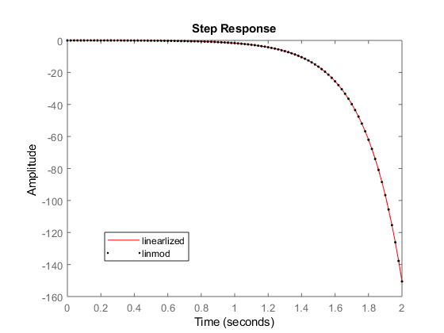

This is the same curve that was expected in the prep

3.2.5 (0.75 mark) Plot the **step response** by using the second way **part b** (with proper labels). Discuss if the result is the same as the one obtained earlier in part a?

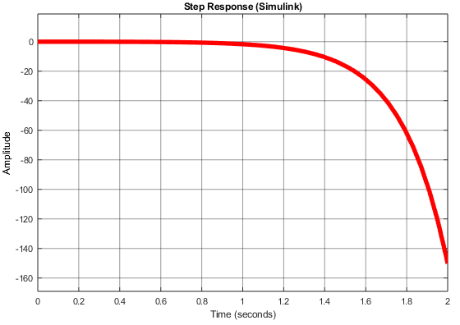

The curves from part a) and b) look identical

(0.5 mark) Summarize your observations

The impulse response obtained from the linearized model, MATLAB’s linmod, and the Simulink simulation are all the same and they indicate that the ball will eventually fall